**Programming Assignment 2 Cloud Computing**

**Name : Venkanna Dharavath**

**UCID : VD348**

**GitHub –**

**DockerHub -** <https://hub.docker.com/repository/docker/venkanna369/wine_production/genera>

1. Log into the AWS Management Console.

The Amazon EMR service, which may be accessed via the service list. Next, select EMR on EC2 Clusters.

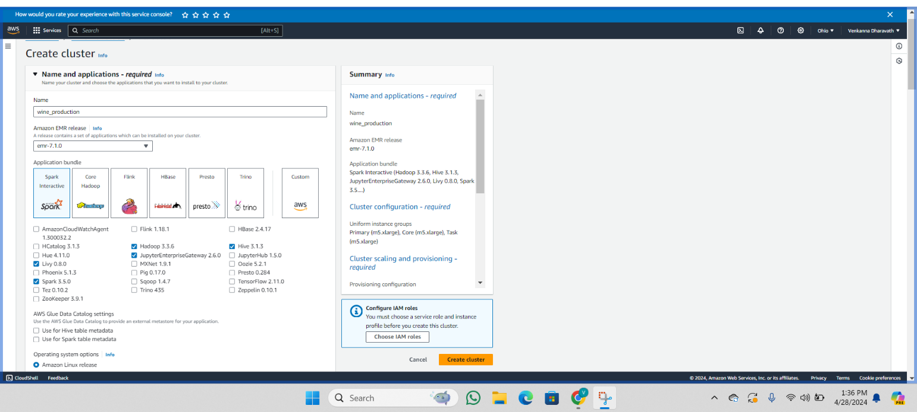

2. The Clusters page will open and you will notice that there aren't any clusters that are currently in use.

1. To create a new cluster, click on the "Create cluster" button.

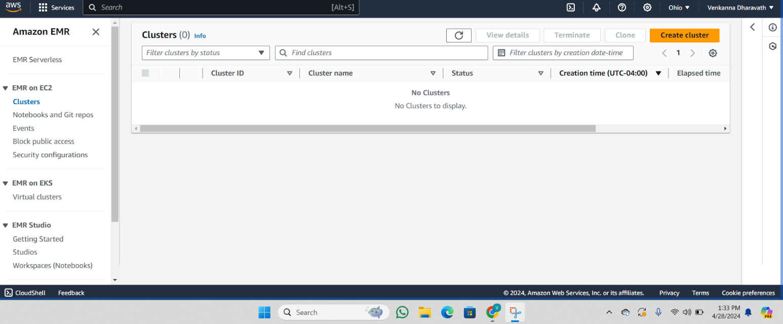

3. You can give the cluster whatever name you like. Additionally, make sure you pick "Spark Interactive" from the Application bundle options and the most recent version of EMR that is available.



1. For the Core, Task, and Primary instance groups, I chose the instance type m5.xlarge. Any instance type that best meets your needs can be chosen by you.

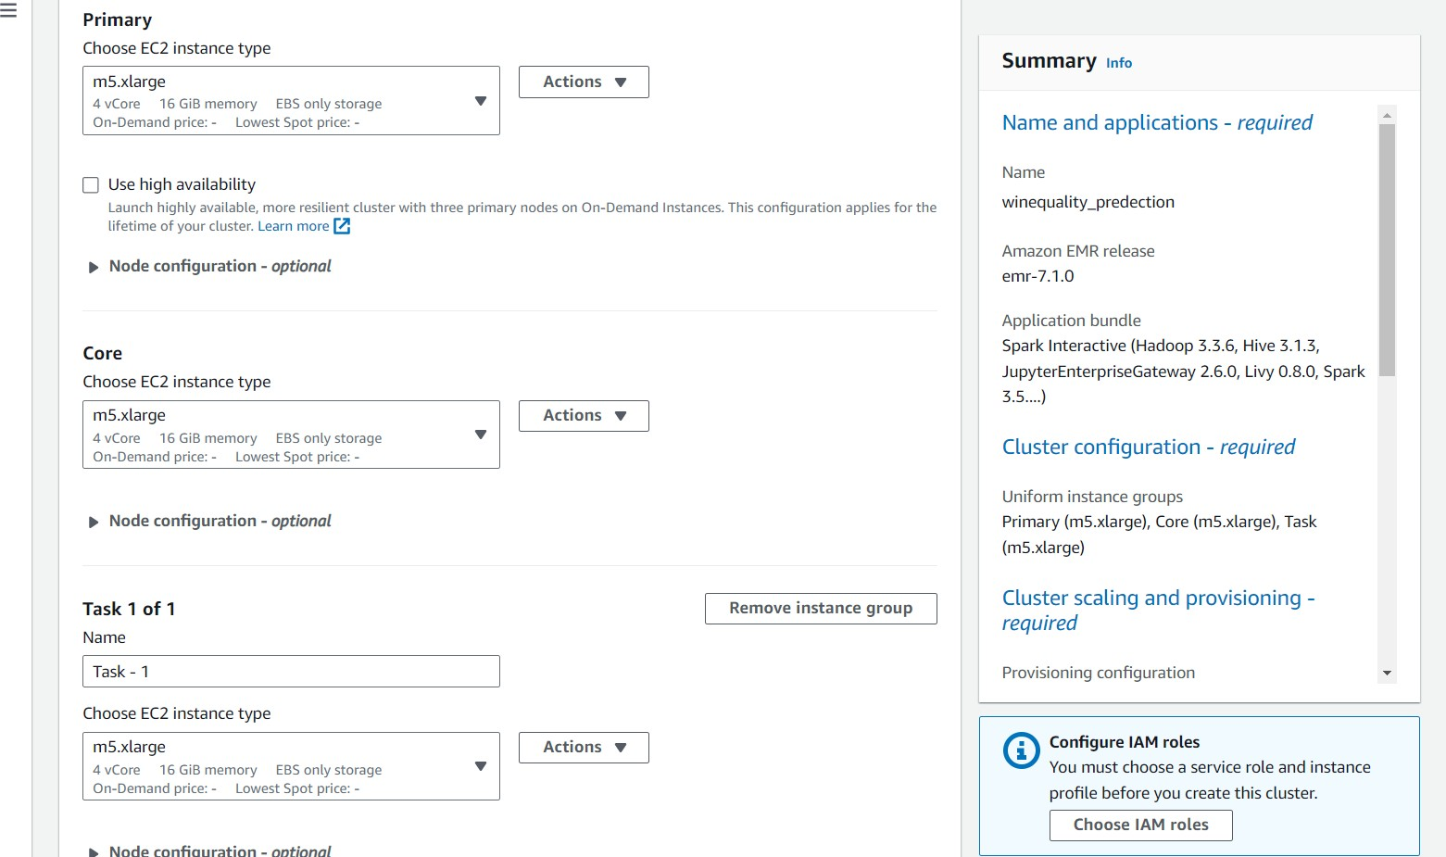

2. Set the instance sizes of Core and Task-1 to 1 and 2, respectively, to provide cluster scalability and provisioning.

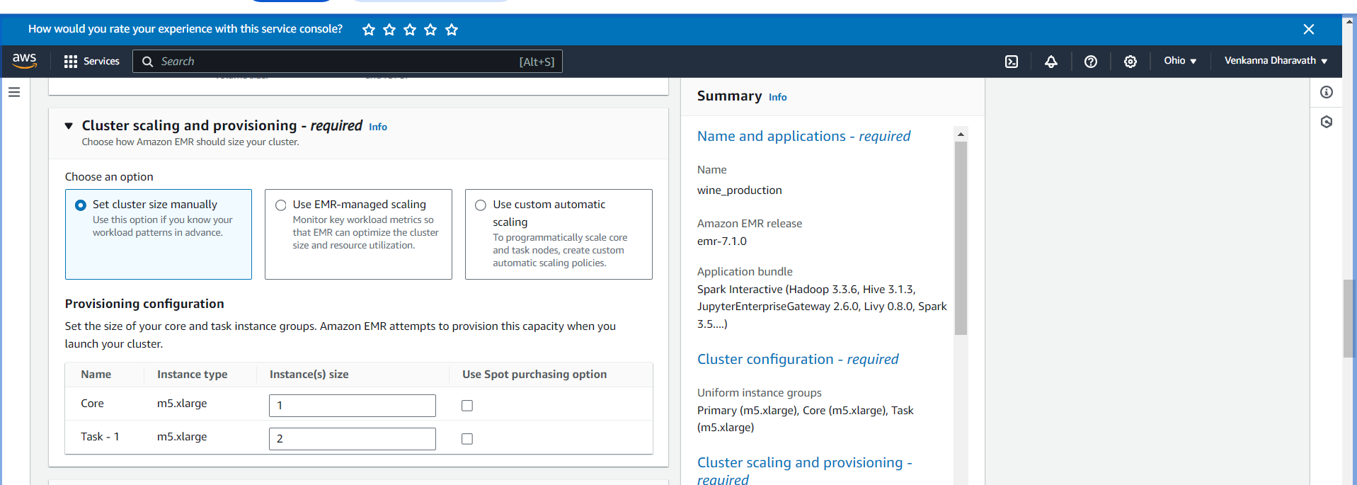

1. In order to pick the security groups for EC2's Primary node, Core, and task nodes, select the security groups that are displayed below.

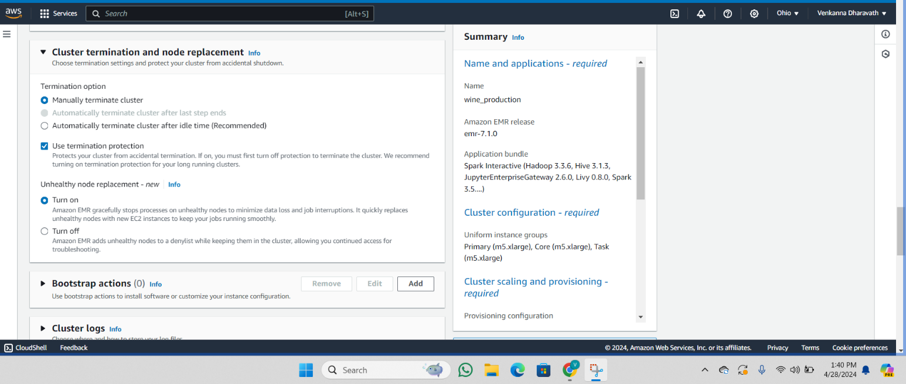

1. To prevent the cluster from being terminated automatically, make sure that the option to manually end the cluster is selected.
2. 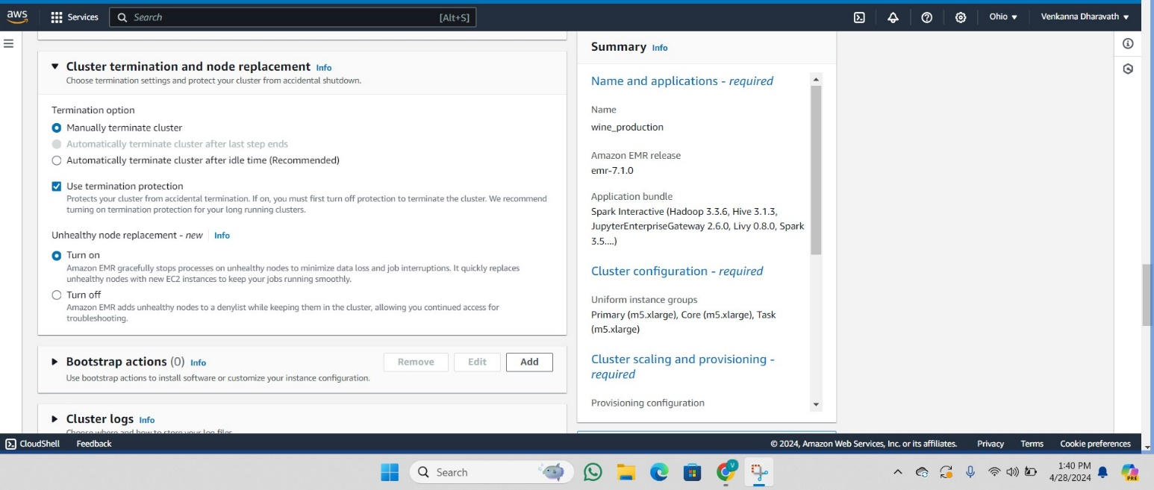
3. create a new key pair

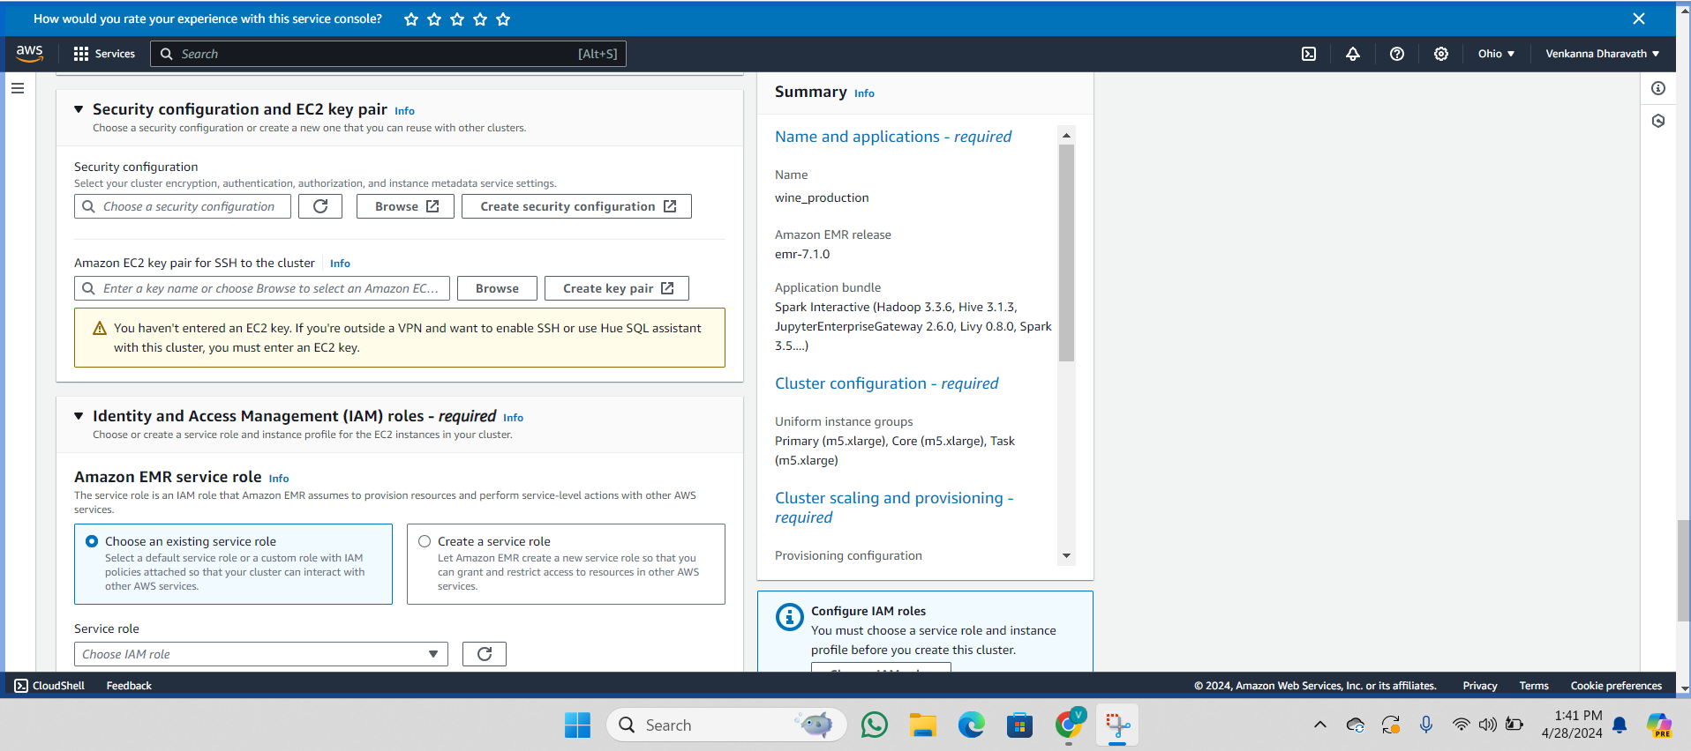

1. Provide a custom name for the key pair and select 'ppk' as the file format when creating the key pair

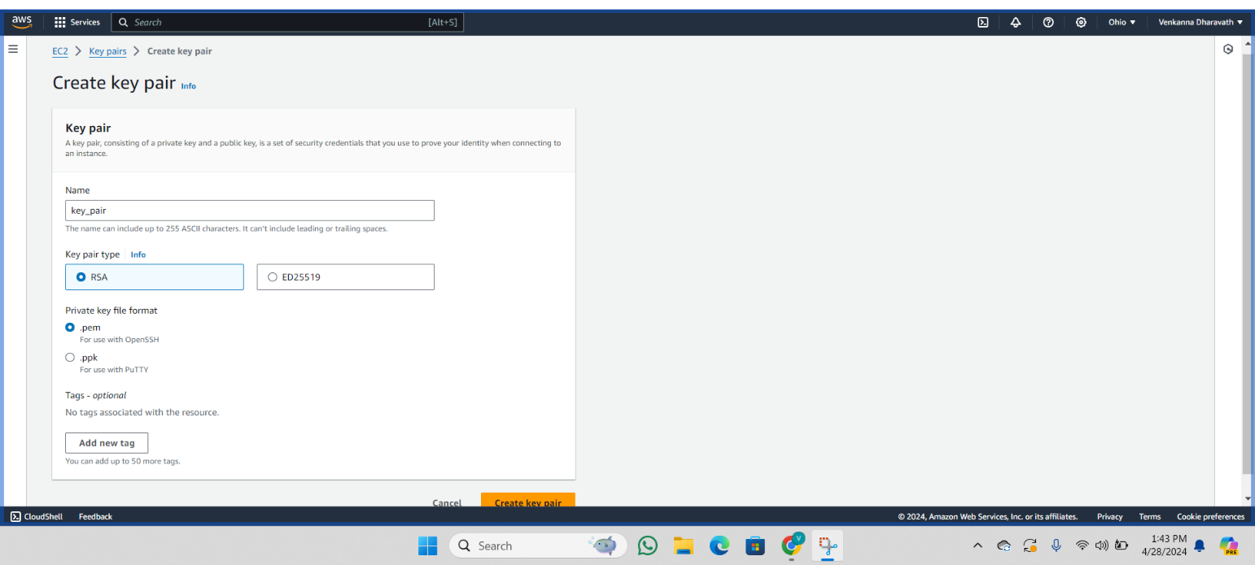

1. The key pair named 'programming-2' has been created, and the key has been downloaded and stored on the local system for connecting to the cluster using PuTTY as the SSH server.

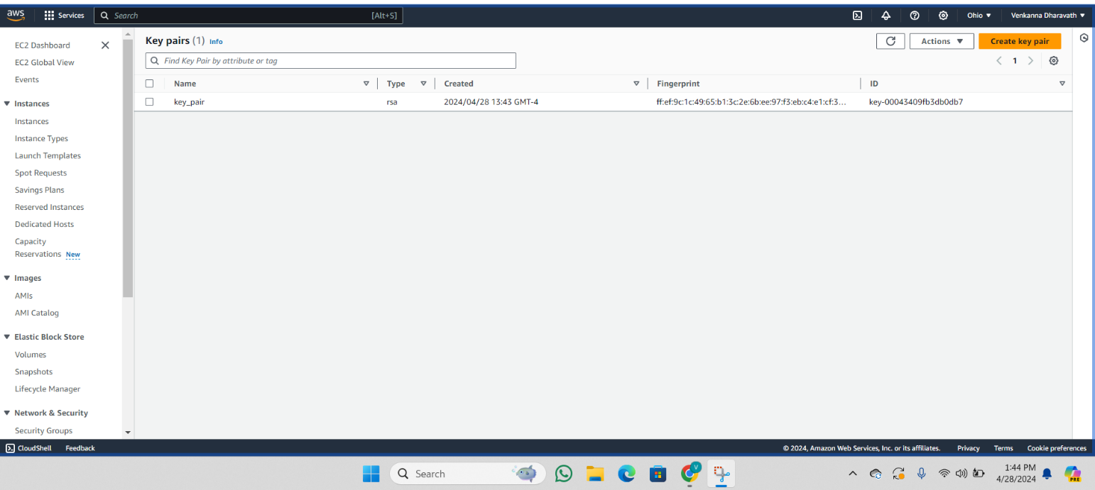

1. The key pair named 'programming-2' has been created, and you can now browse the key .



1. Go to the IAM roles and choose them as indicated below.

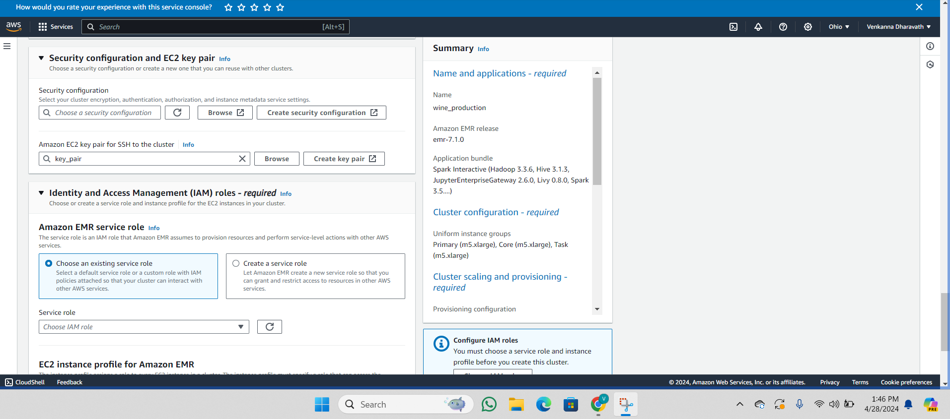

1. Click the button labeled "Create Cluster" to initiate the process of creating the clusters.

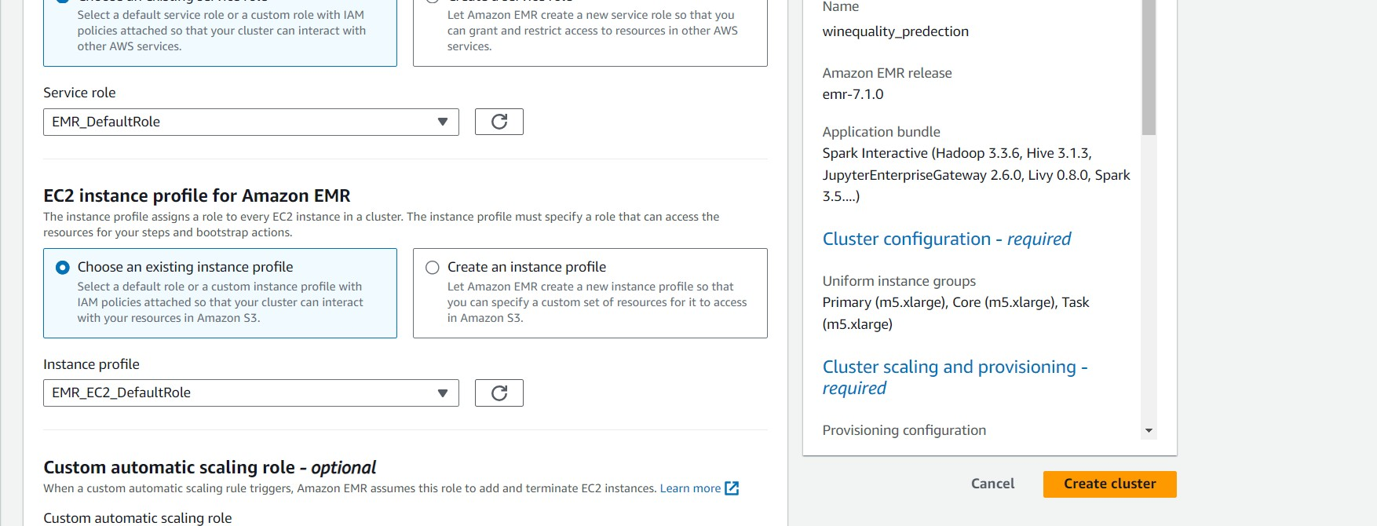

1. Cluster created successfully.

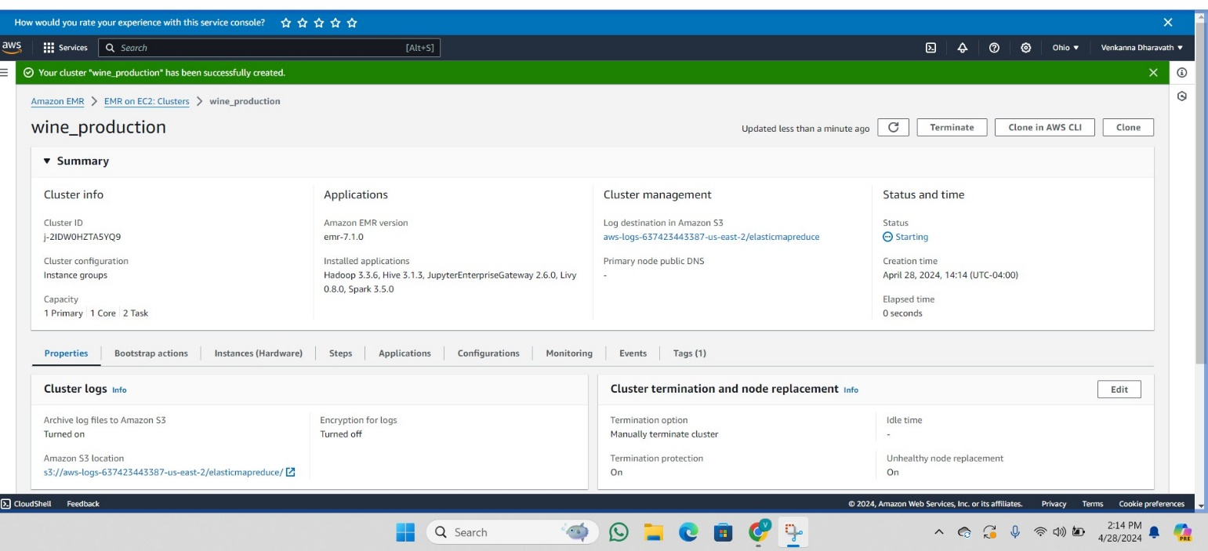

1. Navigate to the EC2 instance page. As seen below, there are four EC2 instances launched, one of which is a Master node and the other three are Slave nodes.

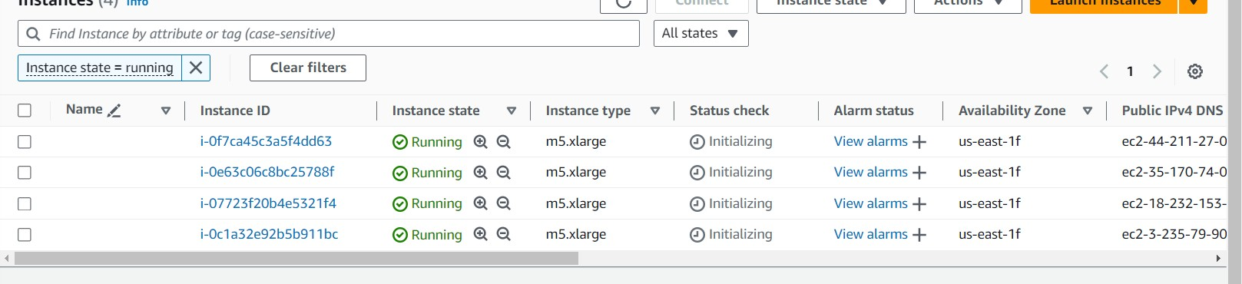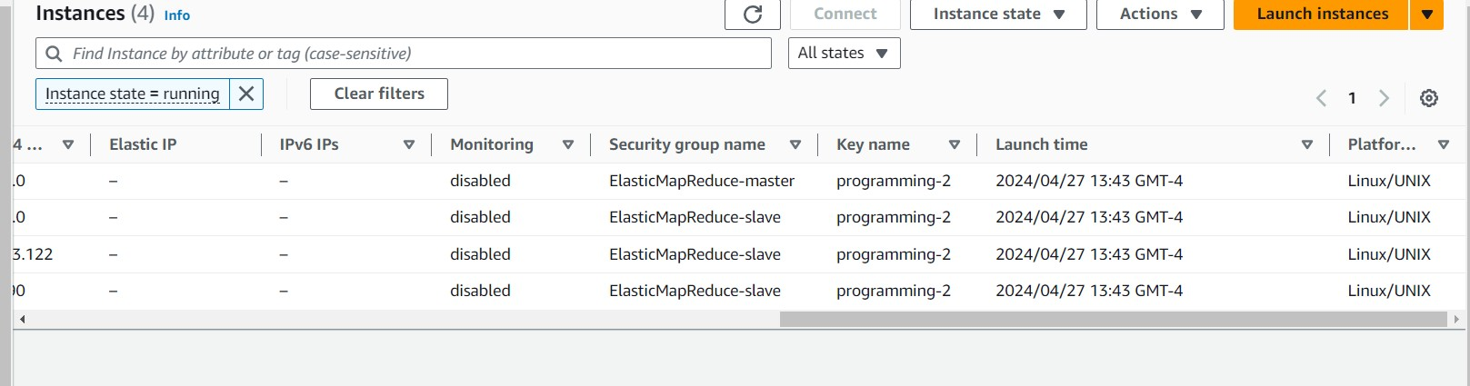

1. To access the "ElasticMapReduce-Master" security group, navigate to the EC2 service and select the appropriate Security ID.
2. 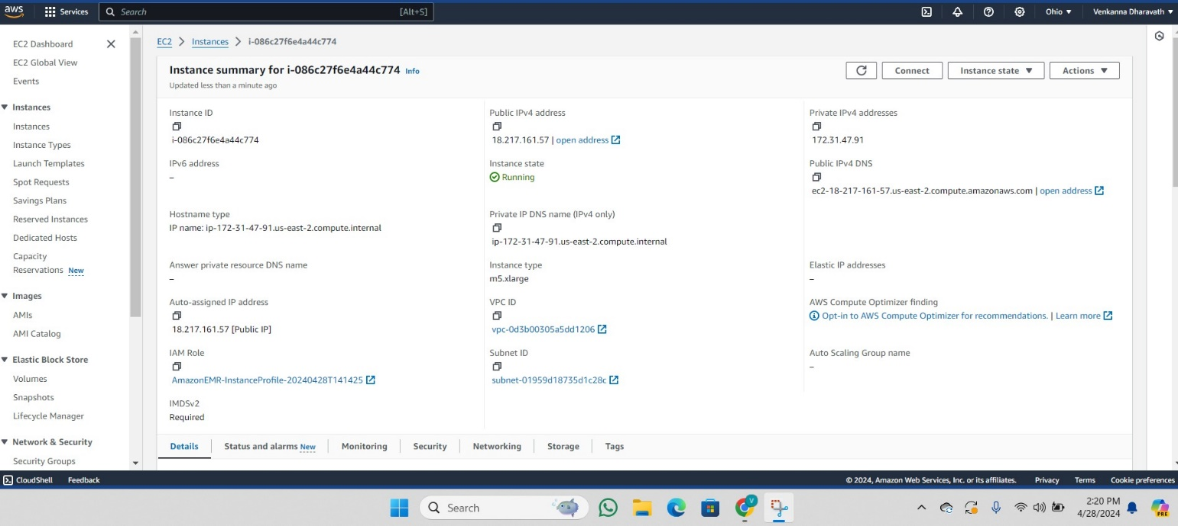
3. Click on the security group to edit its inbound rules

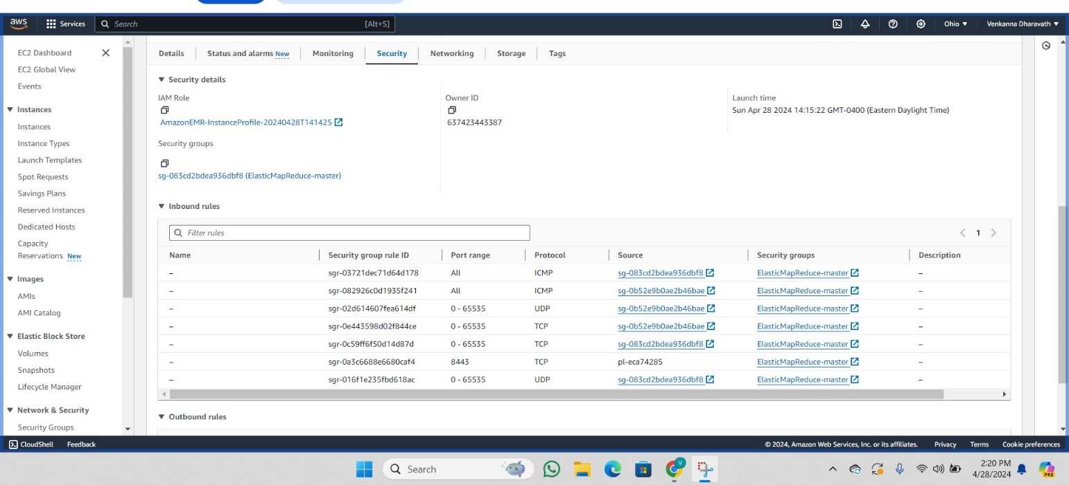

1. In the Inbound Rules section, select Edit Inbound Rules.

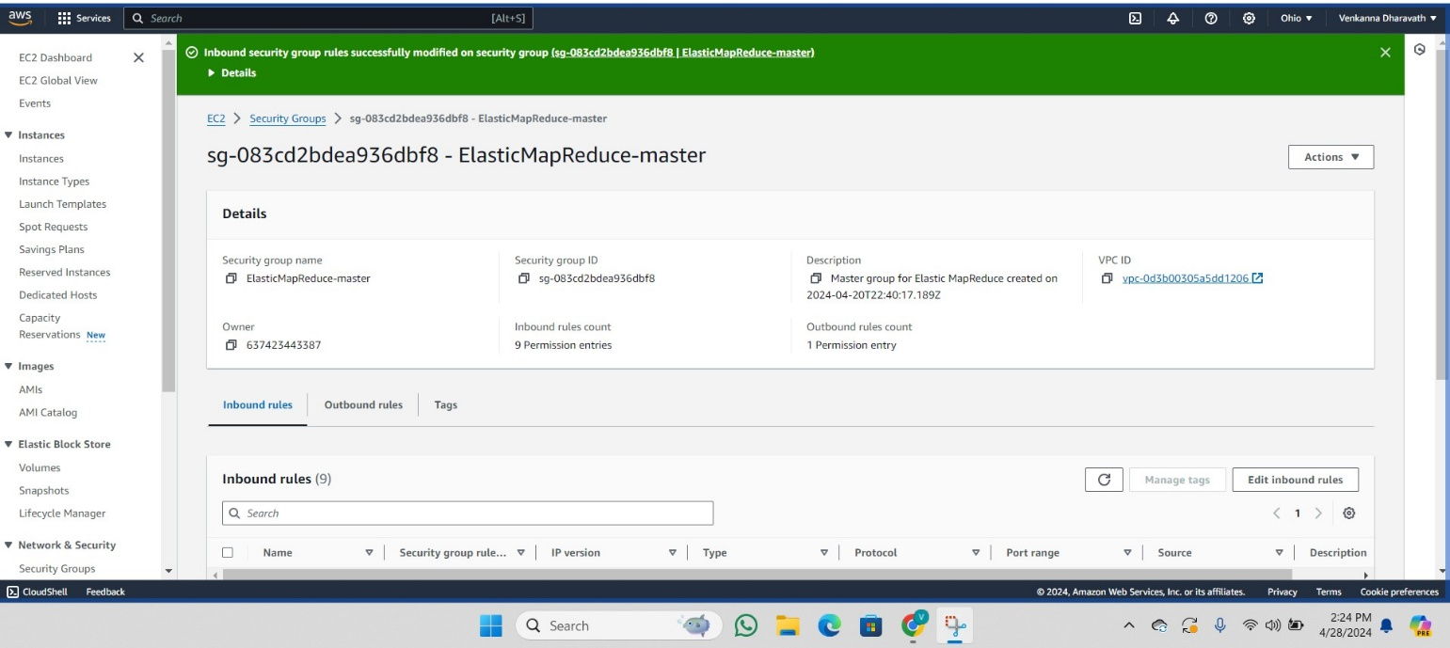

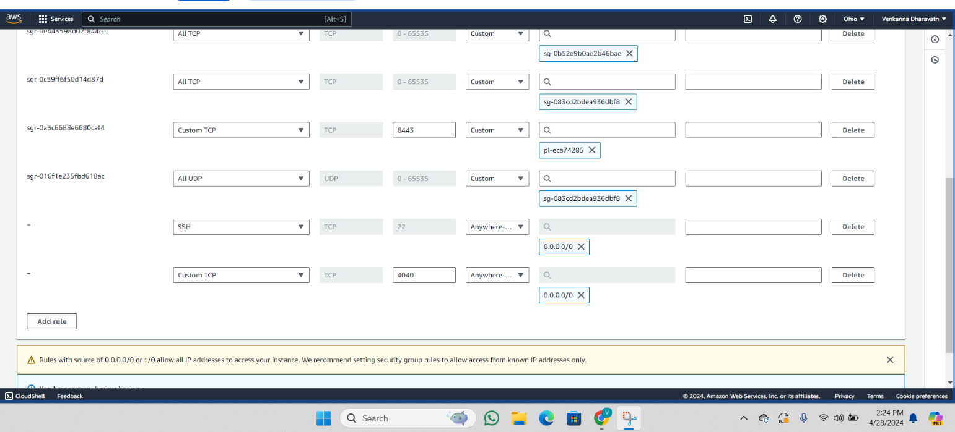

18. With the parameters listed below, enter the port numbers 22 and 4040. Click the Add rule button to save the rules.

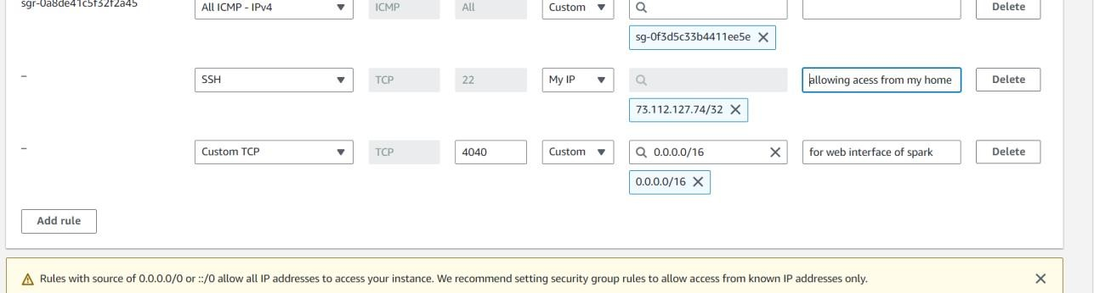



1. Create an S3 bucket in AWS services to store the dataset.
2. Choose "Create Bucket".
3. 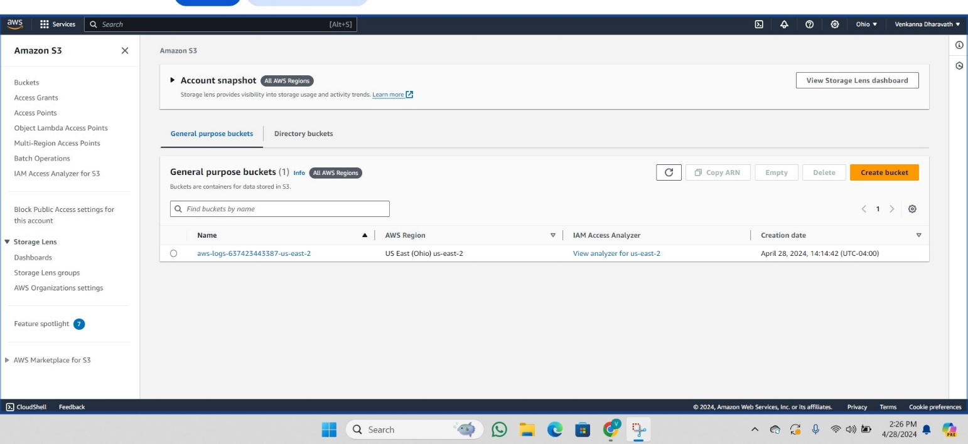
4. Label your bucket as "dataset-programming-assignment-2". Scroll down and click on the "Create bucket" button.



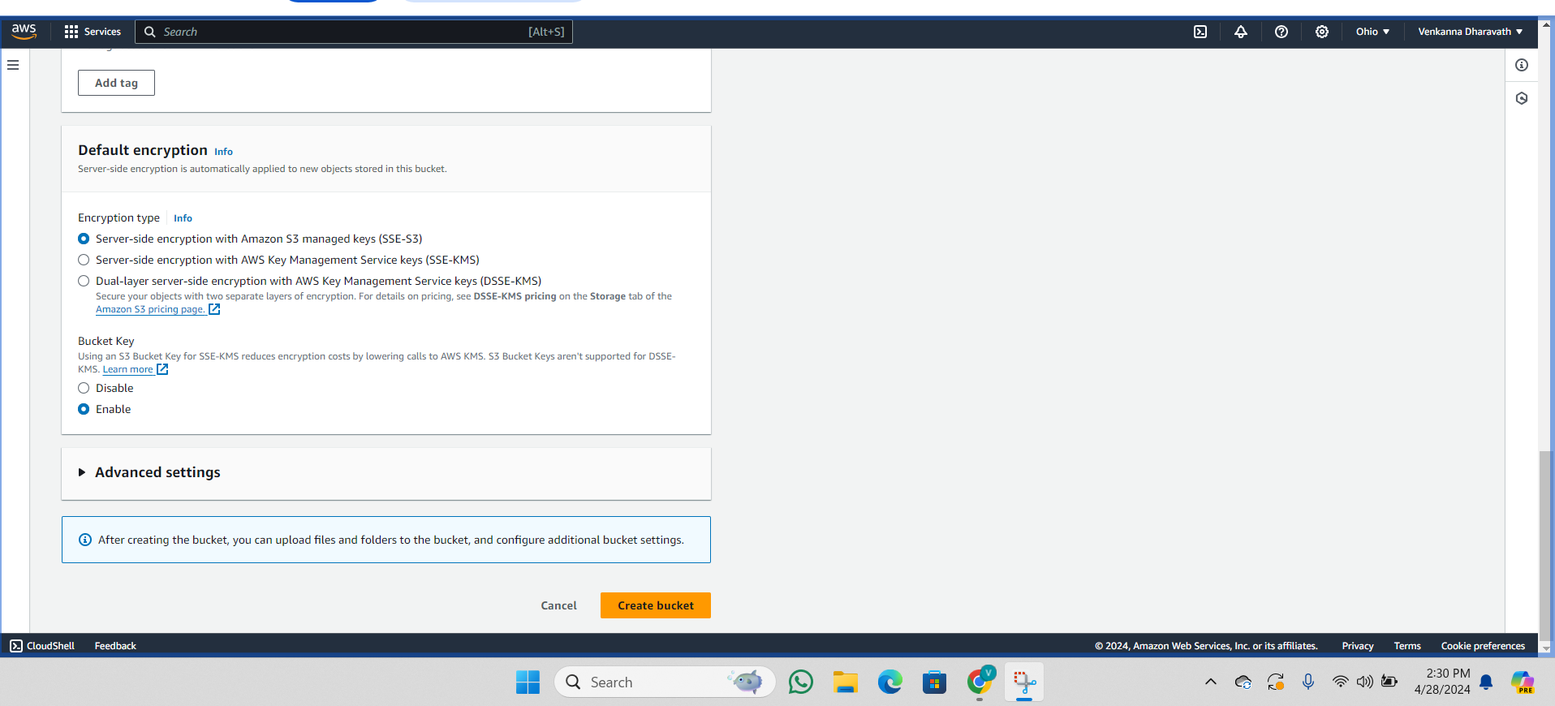

1. Access the buckets page to view your newly created bucket.
2. Click on the bucket name you created.

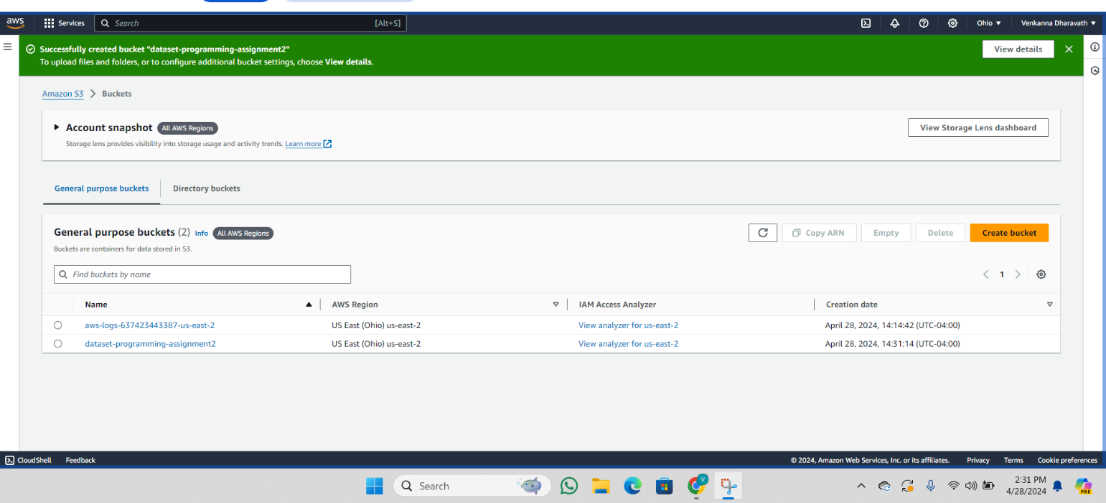

1. Click the upload button.
2. 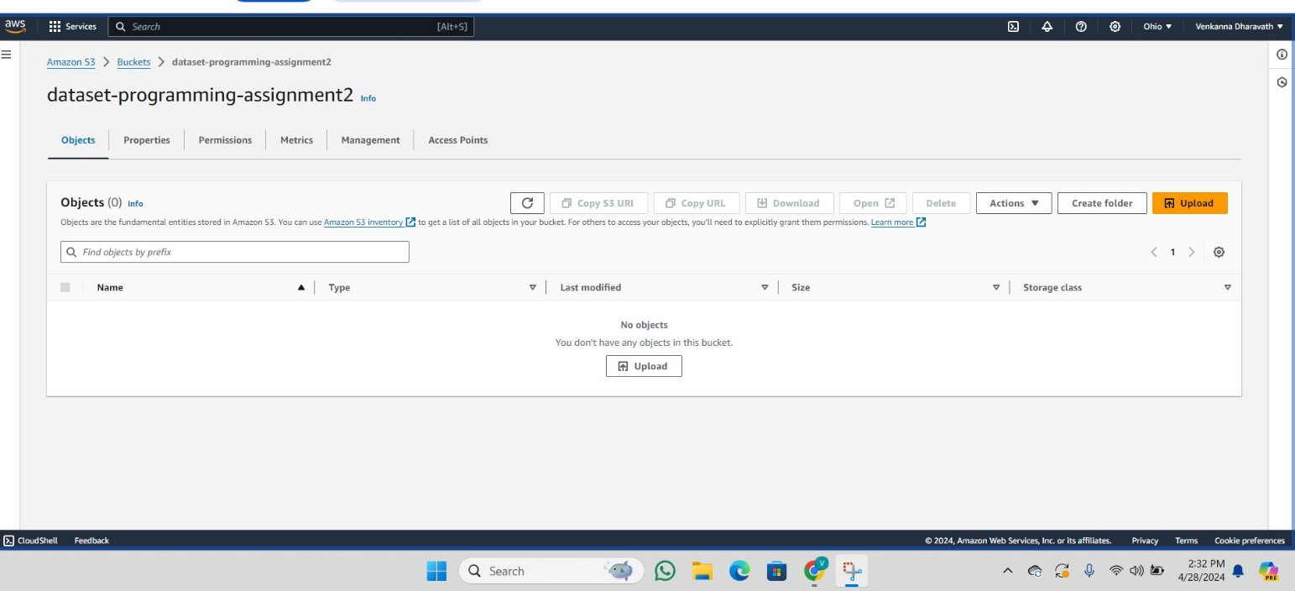

27. From your local system, choose the.csv files by selecting "Add Files." Now, to upload the dataset to the S3 bucket, click the "Upload button". Your S3 bucket now contains the ValidationDataset.csv and TrainingDataset.csv.csv files.

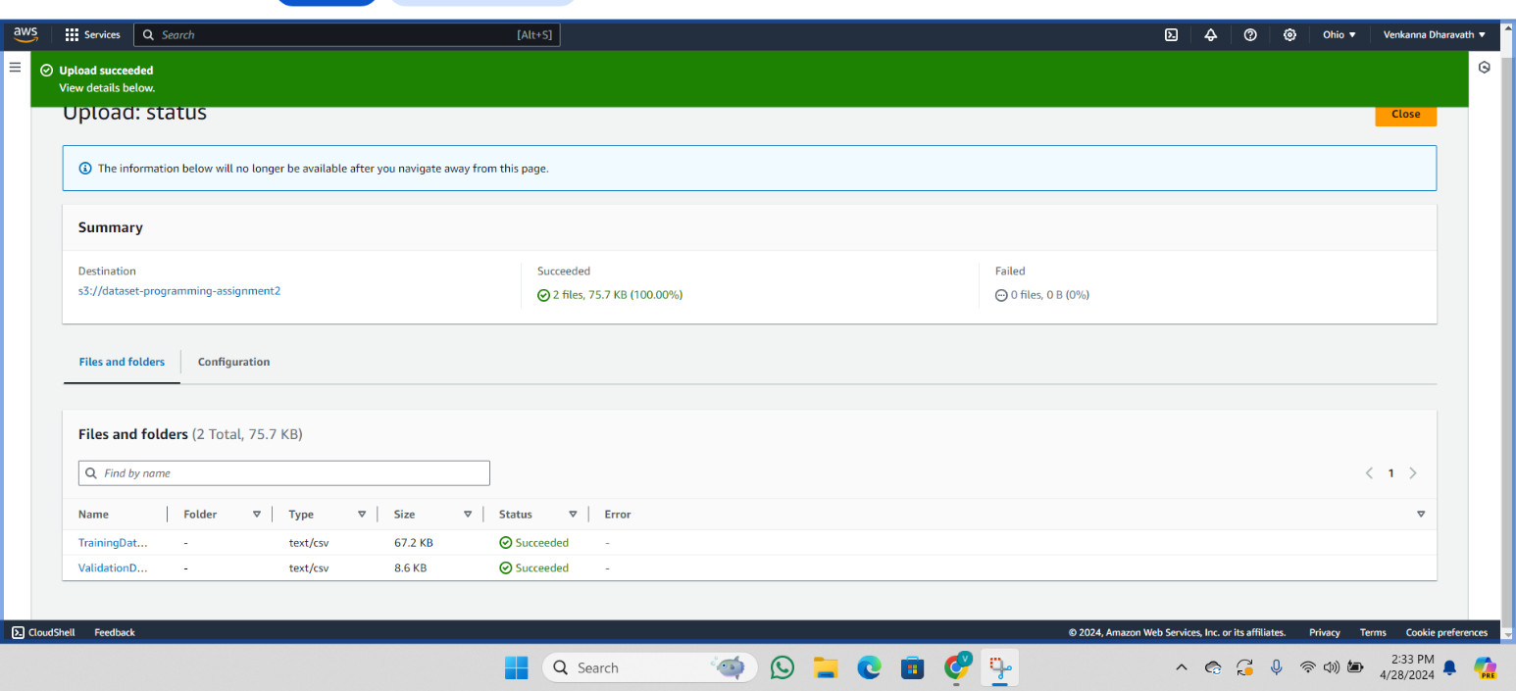

1. Connect to the server using PuTTY by specifying the PPK file for authentication.

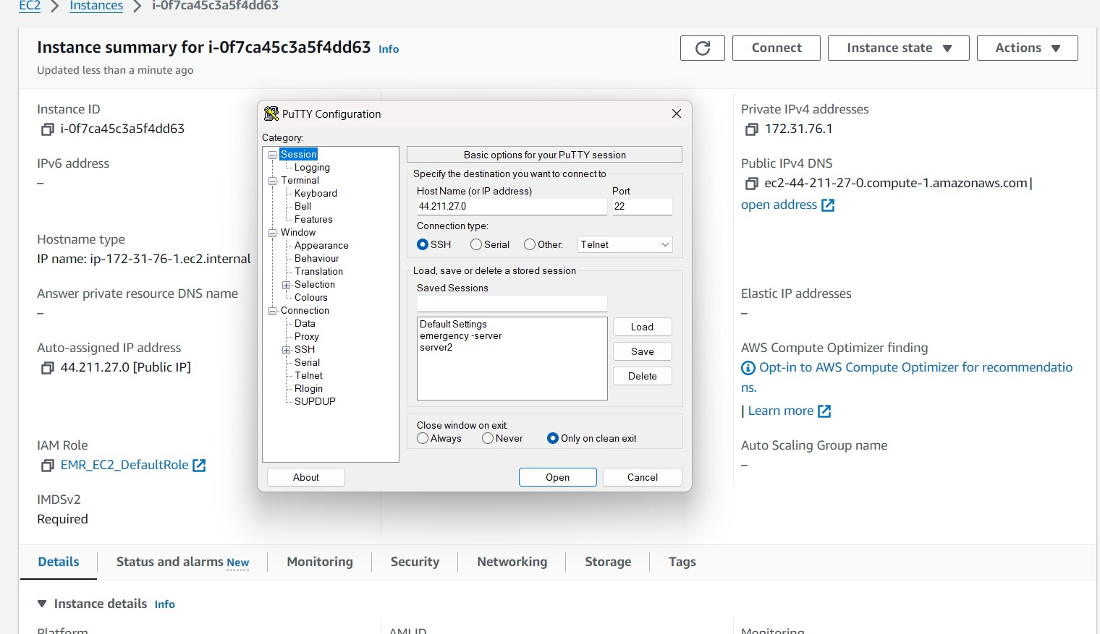

1. Click on "SSH" under "Auth", select "Credentials", provide the path to the location of the PPK file, and then click "Open".

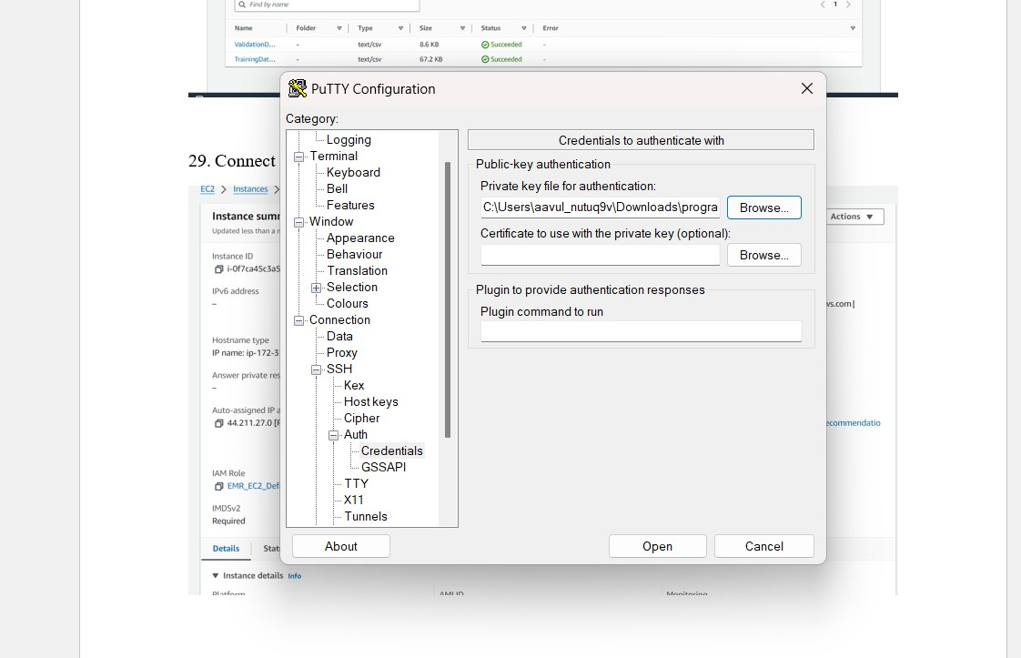

1. click on accept

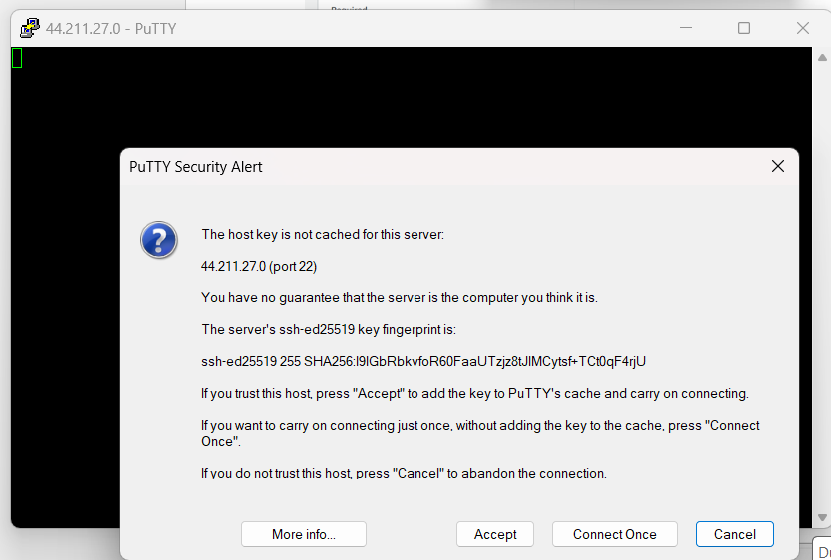

1. provide ec2-user

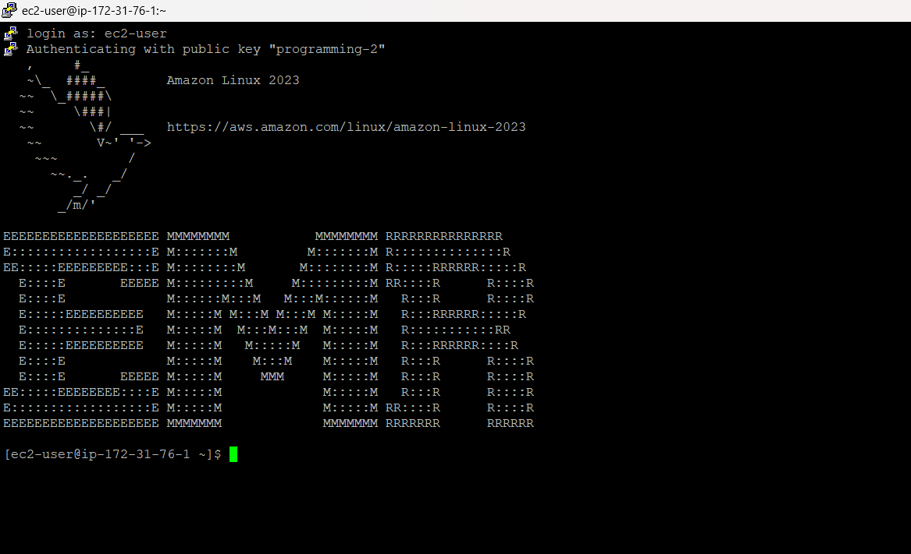

32. Configure the credentials in the EC2 instance of the Master node.   
Enter these commands into your terminal to set up the master node's credentials:

# mkdir .aws

# touch .aws/credentials # vi .aws/credentials

1. Copy and paste the credentials from the AWS Academy page and AWS information.

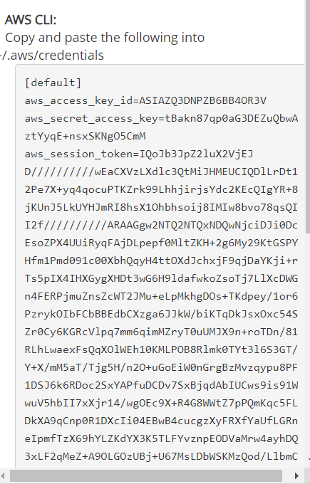

1. To execute our Spark application, we must first install the required packages. Run the commands below:

# sudo yum update.

# sudo yum install git.

# pip install pyspark findspark boto3 numpy pandas scikit-learn datetime

1. To clone the GitHub repository, enter the following command:

#git clone https://github.com/gayatriaavula/winepred_quality.git

1. To get started with the Spark Application, perform the following commands:

# spark-submit --master yarn CS643_Programming_assignment_2/WineTraining.py # spark-submit --master yarn CS643_Programming_assignment_2/WineTesting.py > output.txt

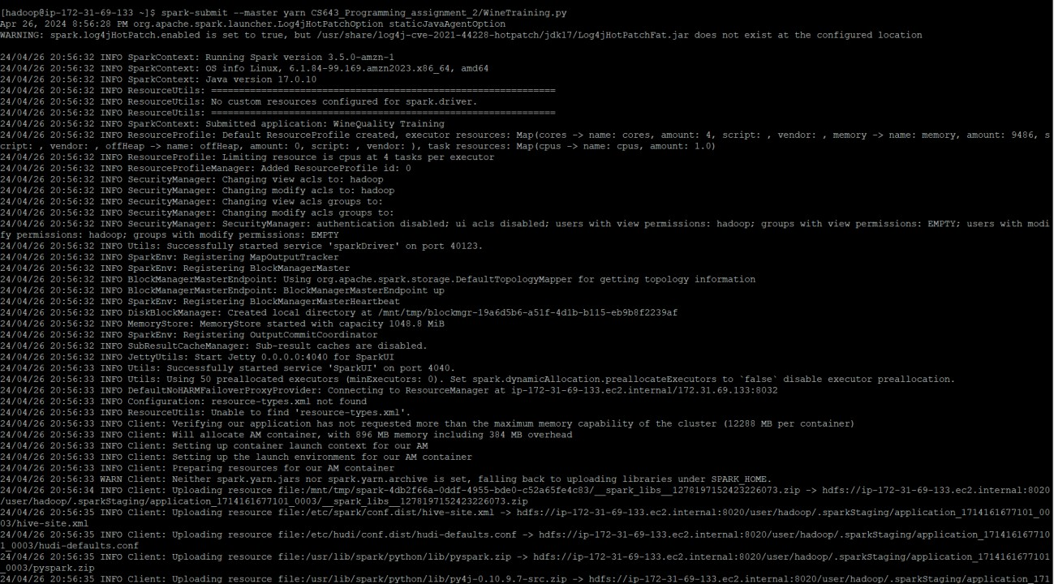

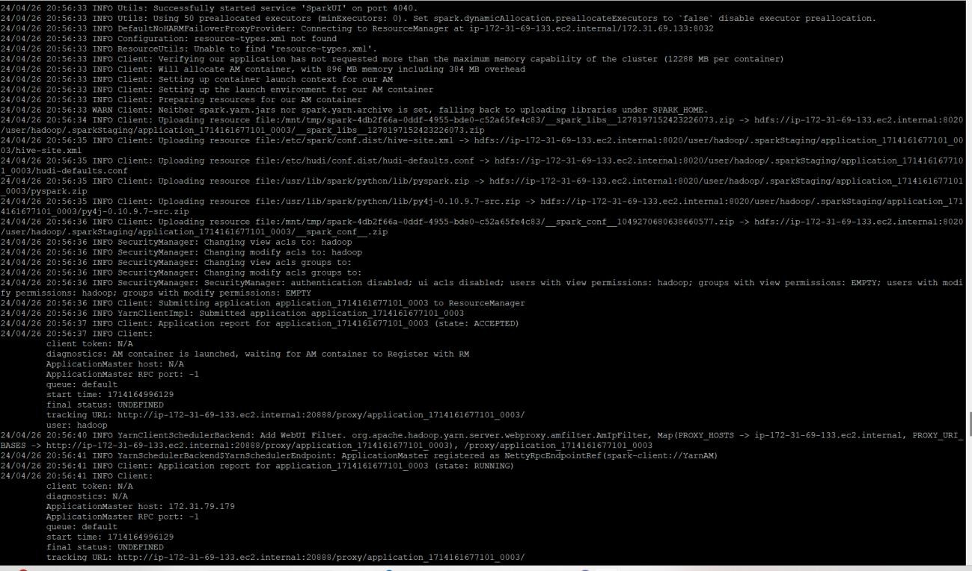

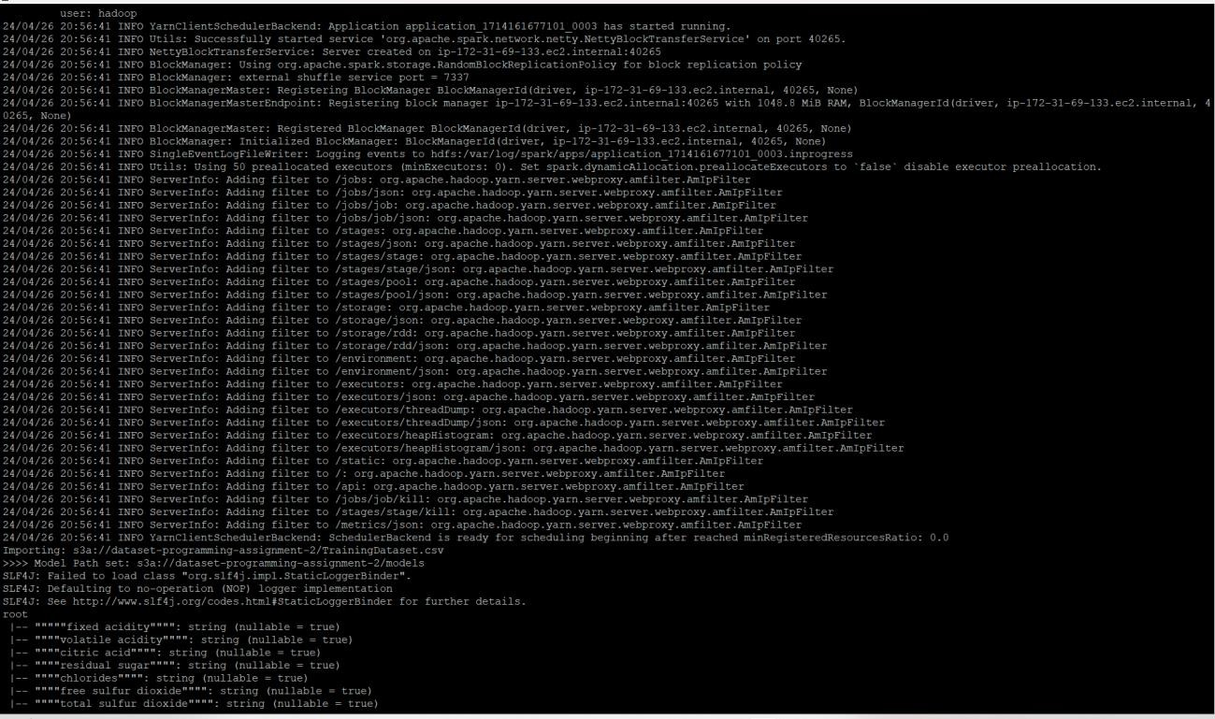

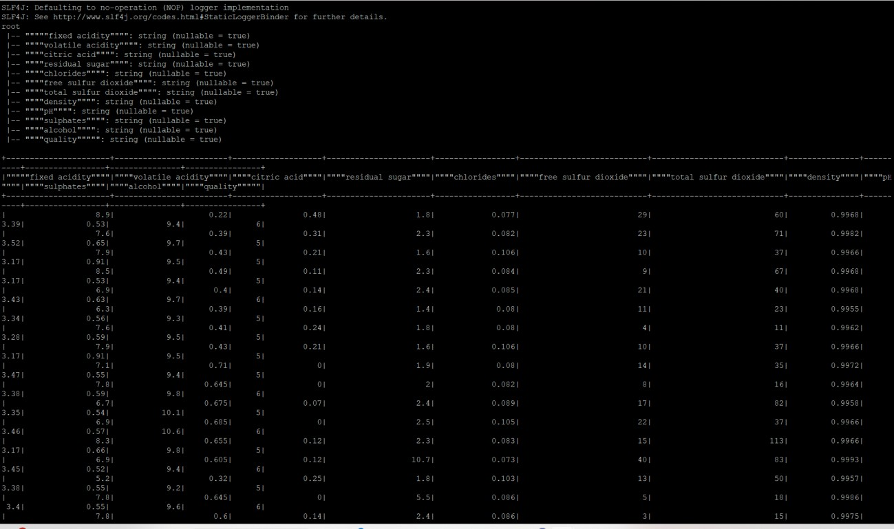

38

The results will be displayed here, along with the Accuracy and F1 scores of the Machine Learning methods used.

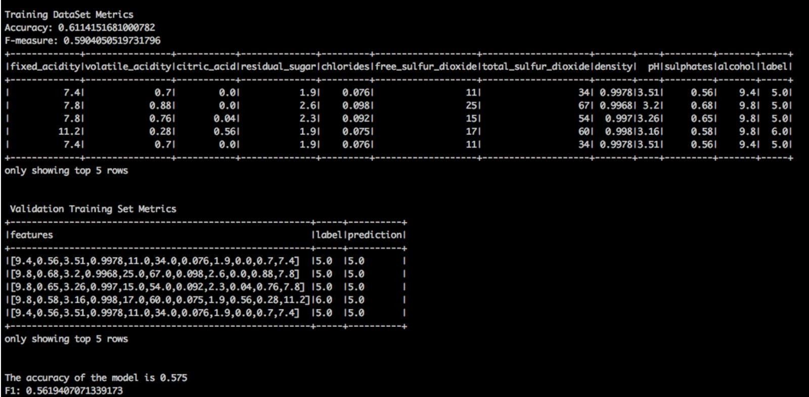

DOCKER IMPLEMENTATION –

1.Update System Packages: sudo yum update -y 2.Install Docker:

sudo yum install -y docker 3.Start Docker Service:

sudo service docker start 4.Check Docker Service Status: sudo service docker status

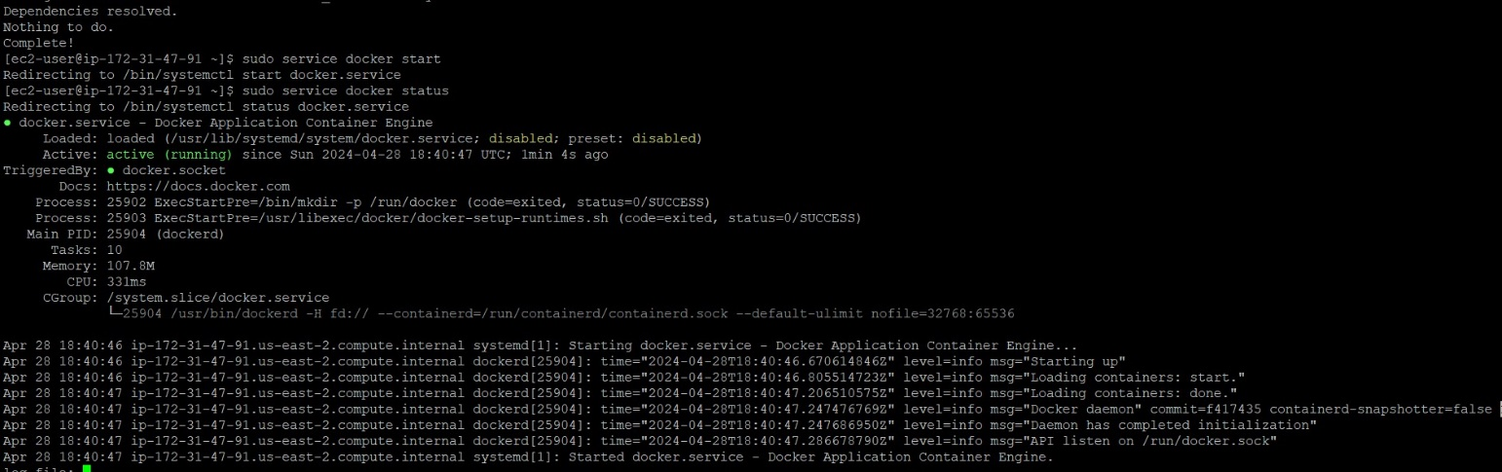

1. Create a Dockerfile and build an image with the docker build command.

sudo dockeí build -t vd348/cs643-píogíamming-assignment-2 .

1. To check if a Docker image was built, use the following command: # sudo docker image ls

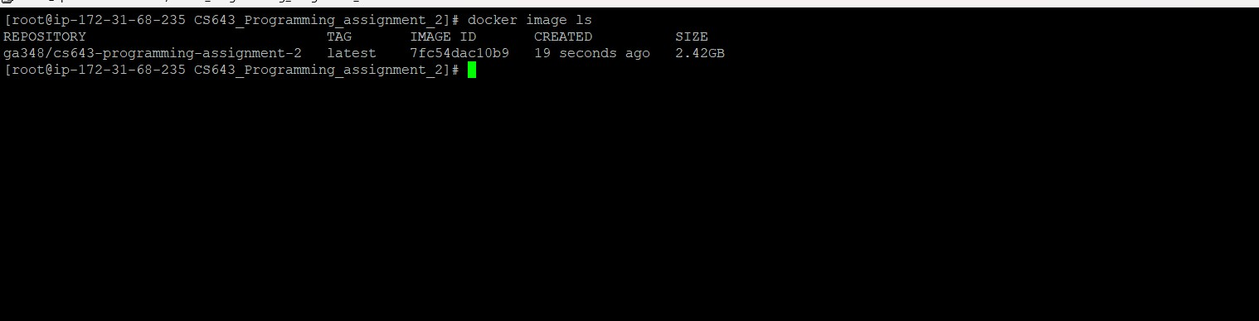

You can see here that your docker image has been built.

1. To run the docker image, use the following command:

sudo docker run -it vd348/cs643-programming-assignment-2

Instead of using the image name, you can use the image ID: # sudo docker run -it 8.This results in the same return for Accuracy and F1 scores.

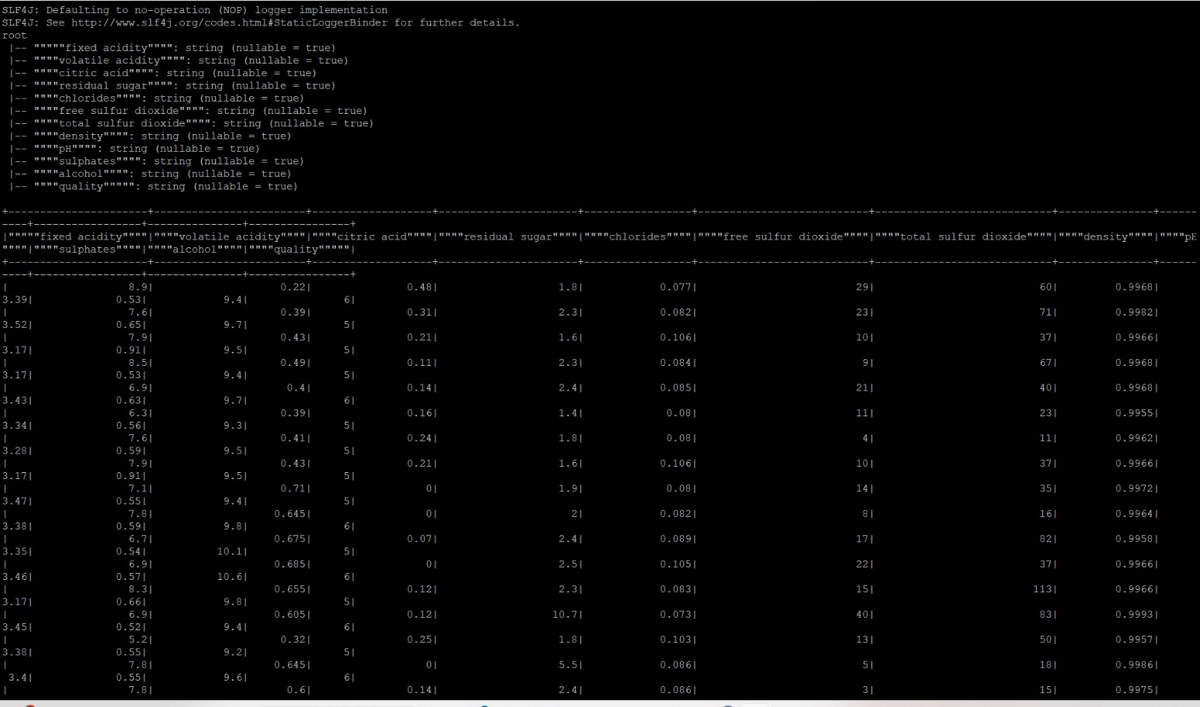

1. Run the following command to submit the produced Docker image to the DockerHub repository:

sudo docker push vd348zcs643-programming-assignment-2

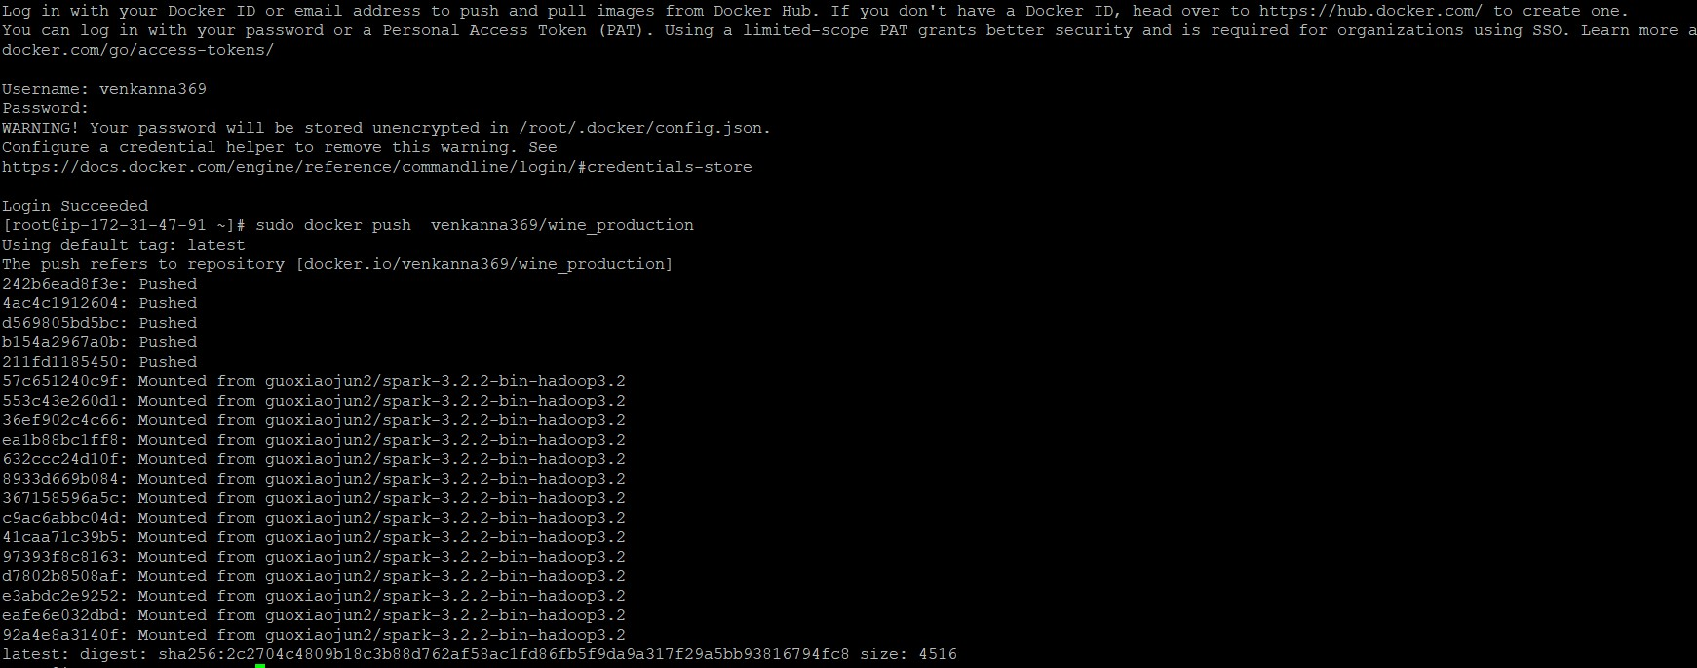

1. Download and execute the Docker image from the DockerHub repository, following the instructions provided on the website.

# Git Bash:

the steps for moving code from my local system to a GitHub repository using Git Bash. 1.git init

1. git add.
2. git status
3. git commit -m “ updated code”
4. git remote add origin https://github.com/gayatriaavula/winepred_quality.git
5. git push -u origin main

